|  |  |  |  |
| --- | --- | --- | --- |
|  | Bansilal Ramnath Agarwal Charitable Trust's  Vishwakarma Institute of Information Technology  **Department of**  **Artificial Intelligence and Data Science** | | |
| Name: Siddhesh Dilip Khairnar | | | |
| Class: SY | Division: B | | Roll No: 272028 |
| Semester: III | | Academic Year: 2022-2023 | |
| Subject Name & Code: Database Management System: ADUA21204 | | | |
| Title of Assignment: Write a database trigger on Employee table. The System should keep track of the records that are being updated or deleted. The old value of updated or deleted records should be added into a new table when the Employee table is updated. Employee (employee no, employee name, join date, designation, salary). | | | |

**Assignment No.- 06**

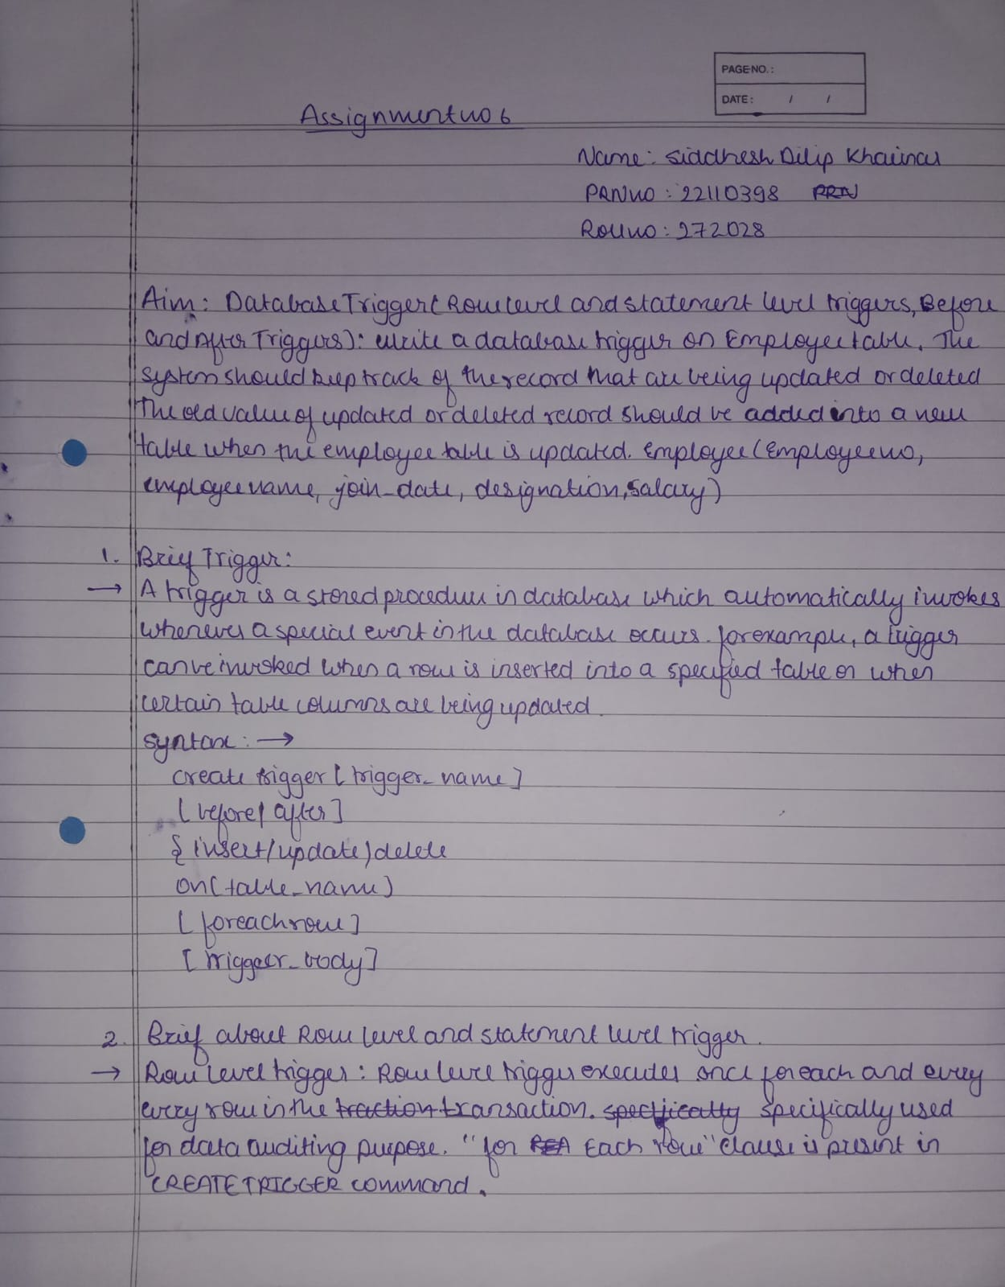

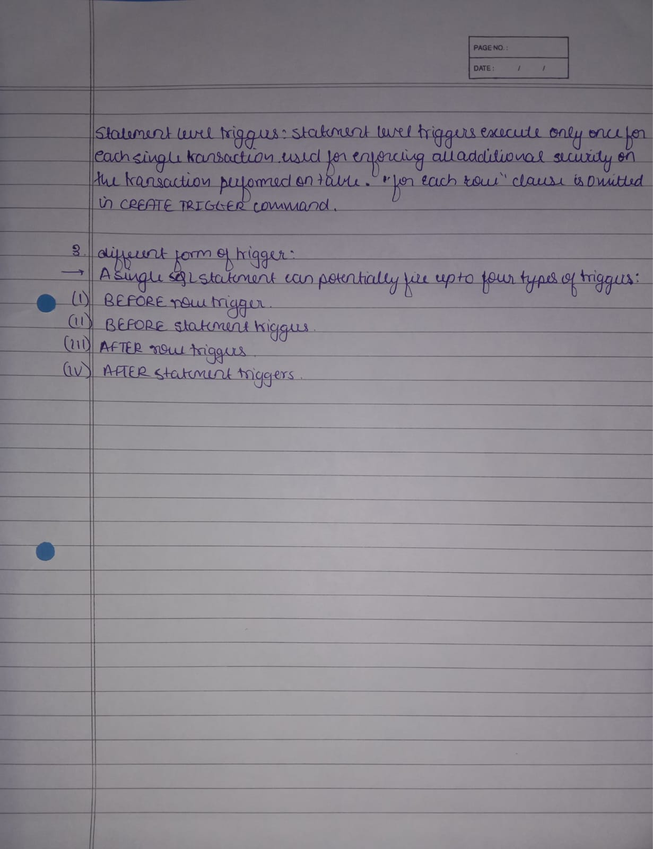

**Implementation:**

**Old employee table**

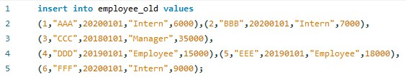

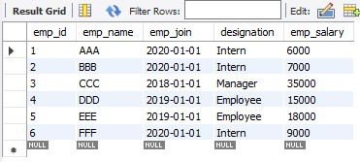

**Before update trigger command**

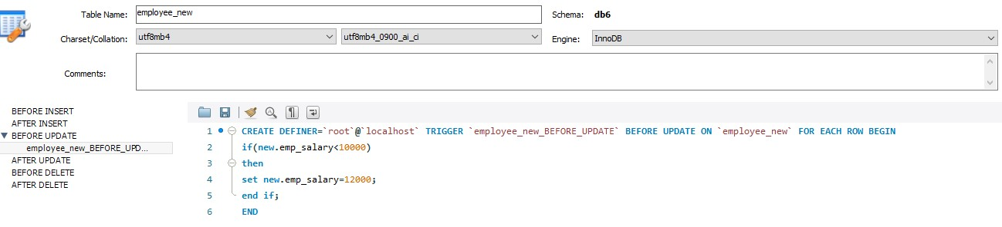

**Before update trigger and generated table**



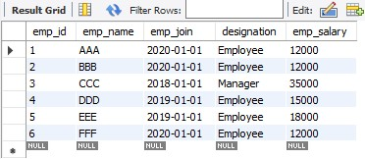

**New Employee table**

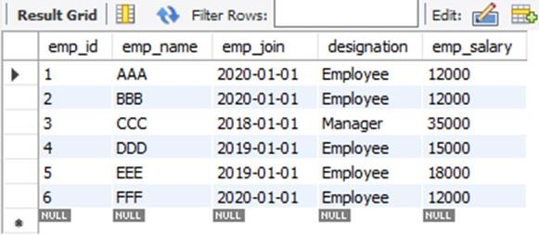

**Before delete trigger command**

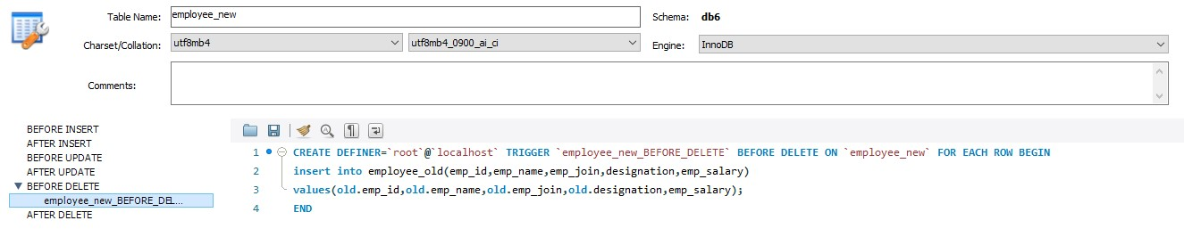

**Old Employee table containing deleted values**



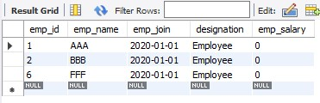

**New Employee table**

